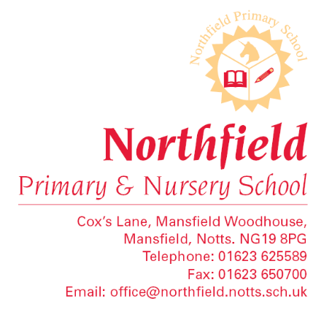

Local Visit Authorisation
Dear Parents/Carers,
During the school year we visit local places of interest within walking distance of Northfield, for example Little Roots, Pleasley Vale, Mansfield Woodhouse Library and The Manor Academy. Rather than ask for your signed permission for each of these local visits we ask that you sign this letter which will then be used as authorisation.
We will of course continue to let you know of local visits your child will be taking part in and continue to obtain parental consent for visits which involve travelling on buses.
We would be grateful if you will sign the consent form below and return to the office as soon as possible. Please include the names of all your children in school.
Thank you in anticipation for your support.
Yours sincerely,
Mrs H Hyatt
Educational Visits Leader
------------------------------------------------------------------------------------------------------------
Parent/Carer permission for local visits
I give permission for my child(ren)--------------------------------------------------------------------

--------------------------------------------------------------------------------------------to take part
in visits walking around Mansfield Woodhouse
Signed--------------------------------------------
Class Teacher(s)-----------------------------------------------------------------------------------------
--------------------------------------------------------

