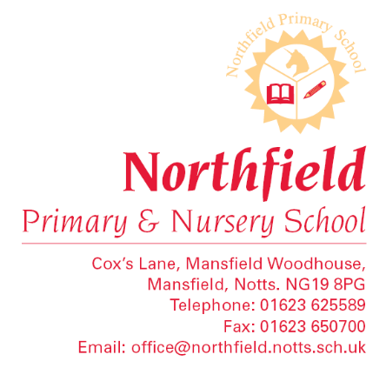

Dear Parent/Carer,
The Department of Education requires that all schools record the nationality, ethnic background, first language and country of birth of all students.
Please could you complete the details below and return the form to school:
Child’s Name________________________________________________ Class__________________
Nationality (as on passport/EEA Identity Card/official document)_____________________________
Multiple Nationality (Dual Nationality if applicable)________________________________________
Country of birth (e.g. Scotland, France, Pakistan etc..)______________________________________
First language is the language your child heard first as a baby. It will be a language they still have contact with at home or in the community, even if they usually speak English now.
Child’s first language:________________________________________________________________
Child’s ethnic group (please tick one box):
White |  | Black or Black British
White - British |  | Black - Caribbean
White – Irish |  | Black – African
Traveller or Irish heritage |  | Any other Black background
Any other white background
Gypsy/Roma |  | Chinese
Mixed/Dual background |  | Any other ethnic group
White and Black Caribbean
White and Black African |  | I do not want my child’s ethnic background to be
White and Asian |  | recorded
Any other mixed background
Asian or Asian British
Indian
Pakistani
Bangladeshi
Any other Asian background

If you have any further queries please contact the school office on (01623) 625589.
Yours sincerely
Ms J Jenkins
Head Teacher

